**A**

**Project Report**

**ON**

**“WEATHER FORCASTING”**

**Submitted in partial fulfilment for the award of degree of**

## Bachelor of Technology [B.Tech] Year (3rd)

## (Computer Science and Engineering)

**To**

**Department of Computer Science**

**Dr. A.P.J. Abdul Kalam Technical University**



**Dev Bhoomi Group of Institutions, Saharanpur**

7 Km. Milestone Dabki Road, Village Beri Jamapur, via Civil Hospital, Saharanpur, Uttar Pradesh 247001

**Under The Supervision of Submitted By**

**Miss. Annu Sinha Aakash**

**Dev Bhoomi Group of institutions, Saharanpur Roll No.:2105020100001**

**Assistant Professer Batch:2021-2025**

# Acknowledgement

ThemostawaitedmomentofanyEndeavourissuccessfulcompletion,butnothingcanbedonesuccessfully if done alone. Success is the outcome of contribution and consistent help ofvariouspersonsandwethankthoseoneswhohelpedusinsuccessfulcompletionofthisproject.

First and foremost, we would like to “Dr. DEEPAK RAJ THAKUR”, Director DBGI forprovidingahealthyand encouragingenvironment to study.

We profusely thankful to the “MR. AJEET KUMAR” HOD Dept. CSE IT and our guide“MISS. ANNU SINHA” Both have been generous enough to provide us anopportunity and accepting our candidature for the most valuable guidance and affordabletreatmentgiven to us at everystageto boost our morale.

We express our sincere gratitude to our colleagues with whom we have fruitful discussionswhichhavehelped us alot in givingafinalshapeto theprogram.

Aakash (B.tech CSE 5th Sem)

Declaration

I hereby declare that the project work entitled**“Weather Forcasting”** submitted to the “**Dev Bhoomi Group of institutions”**, is a record of an original work done by me under the guidance of “**Miss. Annu Sinha**” and this project work has not performed the basis for the award of any Degree or diploma/ associate ship/fellowship and similar project if any.

Aakash (B.tech CSE 5th Sem)

Certificate



This is to certify that Aakash, student of 5th semester under doing B.Tech CSE, have completed the Project Entitled: **Weather ForcastingUsing** the HTML, CSS, JAVASCRIPT, API language.

**Dev Bhoomi Group of institutions, Saharanpur**

For the Batch (2021-2025)

Undertheguidanceof:

Miss. Annu Sinha Assistantprofessor

Dept.ofcomputersScience

Dev Bhoomi Group of

institutions,Saharanpur

Table Of Content

Acknowledgement

Declaration

Certificate

Acknowledgement i

Declaration ii

Certificate iii

1. Introduction 1
2. Objective 2
3. SystemAnalysis 3
   1. IdentificationofNeed 3
   2. PreliminaryInvestigation 3
   3. FeasibilityStudy 3
   4. ProjectPlanning 4
   5. SoftwareRequirement Specification 5
4. DataModels 7
   1. DataFlowDiagram 7
   2. ER– Diagram 8
5. Tools/Platformused 9
   1. Softwareuses 9
   2. Hardwareuses 9
6. SoftwareDesign 10
   1. SystemArchitecture 10
   2. ModularDesign 10
   3. User InterfaceDesign 10
   4. Database Design 10
   5. FlowCharts 10
7. Pert Chart 13
8. Project Scheduling 14
9. Appendices 15
   1. Coding&Screenshot 15
   2. Data BaseDesign 56
   3. SiteMap 57
10. Testing 58
    1. TestingTechniquesUsed 58
    2. TestReports for Unit and System Test Case2 59
11. FutureScope andFurther Enhancement 61
    1. MovieTicket DispensingMachines 61
12. Conclusion 63
13. Bibliography 64

1. Introduction

Weather forecasting means the prediction of the weather through the application of the principles of physics, supplemented by a variety of statistical and empirical techniques.

In addition to predictions of atmospheric phenomena themselves, weather forecasting includes predictions of changes on the Earth’s surface climate. These changes are caused by atmospheric conditions like snow and ice cover, storm tides, and floods.

The basis for weather prediction started with the theories of the ancient Greek philosophers and continued with Renaissance scientists. It was followed by the scientific revolution of the 17th and 18th centuries. The theoretical models of 20th- and 21st-century atmospheric scientists and meteorologists helped for the betterment in applications. The so-called synoptic weather map came to be the principal tool of 19th-century meteorologists. This is used today in weather stations and on television weather reports all over the world. All can happen only through a comprehensive weather forecast. Any weather prediction needs a systematic collection of weather record of various places and proper analysis using the data for prediction.

Traditionally, they ‘re written on a piece of paper or post it notes and acts as a memory aid .As technology has envolved,we have been able to create a to-do lists with excel spreadsheets, word document ,to-do list apps, Microsoft to do and google to do list to name a few . You can use to do list in your home and personal life, or in the workplace.

1. OBJECTIVE

When people wait under a shelter for a downpour to end, they are making a very-short-range [weather](https://www.britannica.com/science/weather) forecast. They are assuming, based on past experience, that such hard [rain](https://www.britannica.com/science/rain) usually does not last very long. In short-term [predictions](https://www.britannica.com/dictionary/predictions) the challenge for the forecaster is to improve on what the layperson can do. For years the type of situation represented in the above example proved particularly vexing for forecasters, but since the mid-1980s they have been developing a method called nowcasting to meet precisely this sort of challenge. In this method, radar and satellite observations of local atmospheric conditions are processed and displayed rapidly by computers to project weather several hours in advance. The U.S. [National Oceanic and Atmospheric Administration](https://www.britannica.com/topic/National-Oceanic-and-Atmospheric-Administration) operates a facility known as PROFS (Program for Regional Observing and Forecasting Services) in Boulder, Colo., specially equipped for nowcasting.

Meteorologists can make somewhat longer-term forecasts (those for 6, 12, 24, or even 48 hours) with considerable skill because they are able to measure and predict atmospheric conditions for large areas by computer. Using models that apply their accumulated expert knowledge quickly, accurately, and in a statistically valid form, meteorologists are now capable of making forecasts objectively. As a consequence, the same results are produced time after time from the same data inputs, with all analysis accomplished mathematically. Unlike the prognostications of the past made with subjective methods, objective forecasts are consistent and can be studied, reevaluated, and improved.

Another technique for objective short-range forecasting is called MOS (for Model Output Statistics). Conceived by Harry R. Glahn and D.A. Lowry of the U.S. National Weather Service, this method involves the use of data relating to past weather phenomena and developments to [extrapolate](https://www.merriam-webster.com/dictionary/extrapolate) the values of certain weather elements, usually for a specific location and time period. It overcomes the weaknesses of numerical models by developing statistical relations between model forecasts and observed weather. These relations are then used to translate the model forecasts directly to specific weather forecasts. For example, a numerical model might not predict the occurrence of surface winds at all, and whatever winds it did predict might always be too strong. MOS relations can automatically correct for errors in [wind](https://www.britannica.com/science/wind) speed and produce quite accurate forecasts of wind occurrence at a specific point, such as Heathrow Airport near London. As long as numerical weather [prediction](https://www.britannica.com/dictionary/prediction) models are imperfect, there may be many uses for the MOS technique.

3. System Analysis

Analyses of weather data Weather forecasting begins with an analysis of the current state of the atmosphere, ocean, and land surface. Reliable observations drawn from many platforms, including satellites, radar, weather balloons, surface stations, and aircraft (both crewed and uncrewed) are crucial for generating accurate analyses. Because forecast quality is partially reliant on the quality of the underlying analysis, scientists continue to develop techniques to integrate observations into four-dimensional model representations of the Earth system. In addition to their vital role in weather forecasting, these analyses support scientific investigations designed to help develop improved weather prediction tools and techniques

**3.1 Identification of Need**

System analysis is a process of gathering and interpreting facts, diagnosing problems and the information to recommend improvements on the system. It is a problem solving activity that requires intensive communication between the system users and system developers. System analysis or study is an important phase of any system development process. The system is studies to the minutest detail and analyzed. The system analyst plays the role of the interrogator and dwells deep into the working of the present system. The System is viewed as a whole and the input to the system are identified. The outputs from the organization are traced to the various processes. System analysis is concerned with becoming aware of the problem, identifying the relevant and Decisional variables, analysis and synthesizing the various factors and determining an optimal or at least a satisfactory solution or program of action.

A detailed study of the process must be made by various techniques like interviews, questionnaires etc. The data collected by these sources must be scrutinized to arrive to a conclusion. The conclusion is an understanding of how the system functions. This system is called the existing system. Now the existing system is subjected to close study and problem area are identified. The designer now functions as a problem solver and tries to sort out the difficulties that the enterprise faces. The solutions are given as proposals. The proposal is then weighed with the existing system analytically and the best one is selected. The proposal is presented to the user for an endorsement by the user. The proposal is reviewed on user request and suitable changes are made. This is loop that ends as soon as the user is satisfied with proposal

**3.2 Preliminary Investigation**

Although each project can have unique goals and needs, there are some best practices for conducting any feasibility study:

* Conduct a preliminary analysis, which involves getting feedback about the new concept from the appropriate stakeholders
* Analyze and ask questions about the data obtained in the early phase of the study to make sure that it's solid
* Conduct a market survey or market research to identify the market demand and opportunity for pursuing the project or business
* Write an organizational, operational, or business plan, including identifying the amount of labor needed, at what cost, and for how long
* Prepare a projected [income statement,](https://www.investopedia.com/terms/i/incomestatement.asp) which includes revenue, operating costs, and [profit](https://www.investopedia.com/terms/n/netincome.asp)
* Prepare an opening day [balance sheet](https://www.investopedia.com/terms/b/balancesheet.asp)
* Identify obstacles and any potential vulnerabilities, as well as how to deal with them
* Make an initial "go" or "no-go" decision about moving ahead with the plan

**The preliminary analysis**outlined a governance framework for future decision-making. The study involved researching the most effective governance framework by interviewing experts and stakeholders, reviewing governance structures, and learning from existing high-speed rail projects in North America. As a result, governing and coordinating entities were developed to oversee and follow the project if it was approved by the state legislature.

**3.3 Feasibility Study**

A feasibility study for weather forecasting would typically assess the viability and potential challenges associated with establishing or improving a weather forecasting system. Here are some key factors to consider in such a study:

1. Objectives: Clearly define the objectives of the weather forecasting system. Determine whether the goal is to create a new forecasting system or improve an existing one.

2. Data Sources: Identify the available data sources for weather observations, such as weather stations, satellites, radars, and buoys. Assess the quality, coverage, and reliability of the data. Consider potential limitations or gaps in data availability.

3. Infrastructure: Evaluate the existing infrastructure required for weather forecasting, including computing resources, data storage, and communication systems. Determine if any upgrades or investments are necessary to support the desired level of forecasting accuracy and coverage.

4. Models and Algorithms: Investigate the various mathematical models and algorithms used for weather forecasting. Assess their performance, accuracy, and computational requirements. Consider the need for advanced modeling techniques, such as numerical weather prediction models or machine learning algorithms.

5. Expertise and Workforce: Evaluate the availability of skilled meteorologists, data scientists, and other experts who can interpret weather data and generate accurate forecasts. Assess the staffing requirements and potential challenges in recruiting and retaining qualified personnel.

6. Validation and Verification: Establish a plan for validating and verifying the accuracy of the weather forecasts. Determine the metrics and procedures for assessing the performance of the forecasting system against ground truth observations.

7. User Engagement: Identify the stakeholders and end-users of weather forecasts, such as government agencies, aviation, agriculture, and general public. Understand their specific needs and requirements. Assess the feasibility of providing tailored forecasts to different user groups.

8. Cost Analysis: Conduct a comprehensive cost analysis, considering factors such as equipment, data acquisition, infrastructure, personnel, maintenance, and operational expenses. Determine the funding sources and the potential return on investment.

9. Legal and Regulatory Considerations: Identify any legal and regulatory requirements for operating a weather forecasting system. Ensure compliance with relevant laws, regulations, and standards, including data privacy and protection.

12. Socio-Economic Benefits: Evaluate the socio-economic benefits that can be derived from improved weather forecasts, such as better disaster preparedness, optimized agricultural practices, and efficient resource allocation.

By conducting a thorough feasibility study covering these aspects, you can assess the viability and potential challenges of establishing or enhancing a weather forecasting system. It will help in making informed decisions regarding investments, resource allocation, and system design.

**3.4 PROJECT PLANING**

A project consists of five different phases: initiation, planning, execution, monitoring and controlling, and closure. Planning is the second phase of the [project life cycle](https://www.simplilearn.com/project-life-cycle-vs-product-life-cycle-article), where a plan after the initiation phase is made so the process of execution may begin. The project plan serves as a roadmap for the entire process of [project management](https://www.simplilearn.com/product-management-certification-training-course?source=GhPreviewCoursepages).

Project planning ensures [monitoring](https://www.simplilearn.com/project-controlling-and-monitoring-article) of the budget and schedule at every step. The project plan includes a schedule that guides team members in completing their tasks and helps them in knowing which tool they will need and when. It also helps the team stay engaged for higher project performance. The project plan ensures there is the active participation of all the team members and allows them to have an opportunistic approach towards their work.

Project planning ensures timely testing of the output at every step. When successfully implemented, everyone on the project team can foresee problems before they happen. This creates efficiencies and ensures the successful execution of the plan.

**3.5 Software Requirement Specification**

#### Introduction

ThisSoftwareRequirementSpecification(SRS)isintendedtosetforththespecificationsforcreatingasystemallowingMirajCinemastopurchasemovietickets.Thesystemwillautomatetheticketorderingprocedureandgiveusersamoreconvenient and streamlined experience. Additionally, it will make the theatre staff'sreservationmanagementand record-keepingprocesses moreeffective.

#### FunctionalRequirements

User Interface: The system must feature a simple, user-friendly interface that makesit simple for users to find movies, check show times, choose seats and buy tickets.Additionally, the interface will show pertinent data like movie reviews, synopses, andtrailers.

Ticket Booking: Customers will be able to choose their preferred movie, day, time,and seats (e.g., standard, VIP, or balcony) using the system. Customers will be able touse cash, credit/debit cards, e-wallets, and other payment methods to buy ticketsthroughthesystem.

Reporting: Reports on attendance, revenue, and ticket sales will be produced by thesystem.Reportsmustbemadeavailableinavarietyoffiletypes,includingPDF,CSV,andExcel.

#### Non-FunctionalRequirements

Performance: For each transaction, the system must respond in fewer than 5 seconds.Additionally, the system must be able to handle peak loads during the release of well-liked films.

Security: The system must have adequate security mechanisms in place to safeguardconsumer information, including encryption of private information like credit cardnumbers.

Compatibility:Thesystemmustworkwithdifferentenvironment.Additionally,thesystemmust be responsiveand user-friendly.

#### Assumptions and ConstraintsAssumptions

* Moderntechnologiesincludingfilemanagement,theiomaniplibrary,andOOPprincipleswill beused to construct thesystem.
* Tooperatethesystemeffectively,theatreworkerswillreceivetraining.

#### Constraints

* Withinsixmonths,thesystemmustbedesigned anddeployed.
* Thetechnologymust beintegrated with thetheatre’scurrent technical setup.

#### Conclusion

The goal of the Movie Ticket Booking System (MTB) for Miraj Cinemas is to provideanefficientanduser-friendlysoftwareapplicationthatmakesbuyingticketsformoviessimplerformoviegoers.Thesolutionwillalsoassisttheatreemployeesinmoreeffectivelymanagingreservationsandkeepingrecords.Thesystemdevelopmentprocessmusttakeintoaccountbothfunctionalandnon-functionalrequirements,assumptions,and restrictions.

4.Data Models

* Numerical weather prediction is the use of computers to model the atmosphere and predict how atmospheric motions change both horizontally and vertically with time. There are two basic sizes of models: global (covering the entire Earth) and regional (covering part of the Earth).
* Upon the input of this initial data, the computer will use mathematical equations to calculate a future state of the atmosphere in a "time step". Depending upon the type of model and aerial coverage, a time step interval can be as short as a few seconds or as long as several minutes.

**4.1 Data flow Diagram**

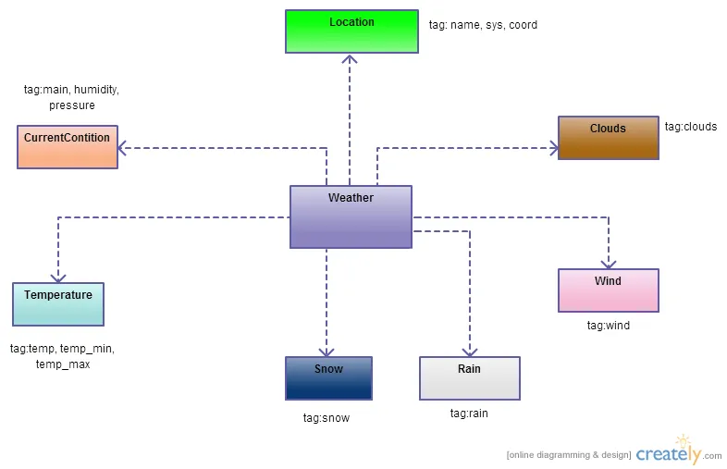

5.TOOLS / PLATFORM USED

## 5.1 Softwareuses

For proper operation, the weather forecasting system makes use of a number ofsoftwaretools and technologies. Utilisations ofthesoftwareinclude:

Programminglanguage:HTML, CSS, JAVASCRIPT,whichoffersthecharacteristicsandcapabilitiesrequiredfor creatingtheapplication,is used to designthe system.

**Development environment integrated (IDE):** an IDE such as Visual StudioCode.The weather forecasting source code is written, edited, compiled, and debugged usingBlocks.

File Handling: The system makes use of the programming language's file handlingfeaturestoreadfromandwritetofiles.Thismakesitpossibletostoreandretrievedataaboutmovie showings, reservations, andother system information.

5.2 Hardwareuses

Certain hardware elements are necessary for the weather forecasting system tofunction and offer its services. Depending on the deployment environment and systemneeds,differenthardwaremaybeusedindifferentways.Hereareafewcommonpiecesofhardwarethat the weather forecastingsystem uses:

Workstations:Thetheatrestaffusesworkstationstoaccessandcommunicatewiththe weather forecasting system. These workstations can be laptops, desktop computers, or tablets withthehardware andsoftwarerequired toexecute the system's userinterface.

Printers: Printers may be used to generate physical tickets or receipts for customerswho prefer printed copies. These printers should be capable of producing high-qualityprintsand beconnected to the workstations orserver for printingpurposes.

# 6. SoftwareDesign

The process of creating the system's architecture, modules, interfaces, and data structures tomeetthefunctionalandnon-functionalrequirementsisknownassoftwaredesignforthe weather forecasting system. The following are some crucial components of the MTBsystem'ssoftwaredesign:

## 6.1 SystemArchitecture

Clients (workstations) communicate with the server to carry out various tasks in a client-server architecture, where the server controls the database and business logic. In order toensure scalability, reliability, and performance, the architecture should be created withpotentialfuture growth and risingclient demand in mind.

## 6.2 ModularDesign

Logical modules of the system, such as user management, movie management, bookingmanagement, paymentprocessing, andreporting,can becreated. Toenable modulardevelopment, testing, and maintenance, each module needs to have distinct roles andinterfaces.

## 6.3 UserInterfaceDesign

The user interface ought to be simple to use, pleasing to the eye, and intuitive. The designshould take into account the many user types, including patrons and theatre workers, andoffertheproperfunctionalities andscreens for each user role.

## 6.4 DatabaseDesign

The database schema should be created to store and retrieve information about movies,reservations, customers, and other pertinent data. To maintain data integrity, relationshipsbetweenentities shouldbecreated usingthe proper keysand foreign keyconstraints.

## 6.5 FLOW CHART

Send Data central server

Start

Data Collected

Welcome

Analysis Data

Found

No

Yes

Display Data

**7. PERT CHART**

A PERT chart is a visual project management tool used to map out and track the tasks and timelines. The name PERT is an acronym for Project (or Program) Evaluation and Review Technique.

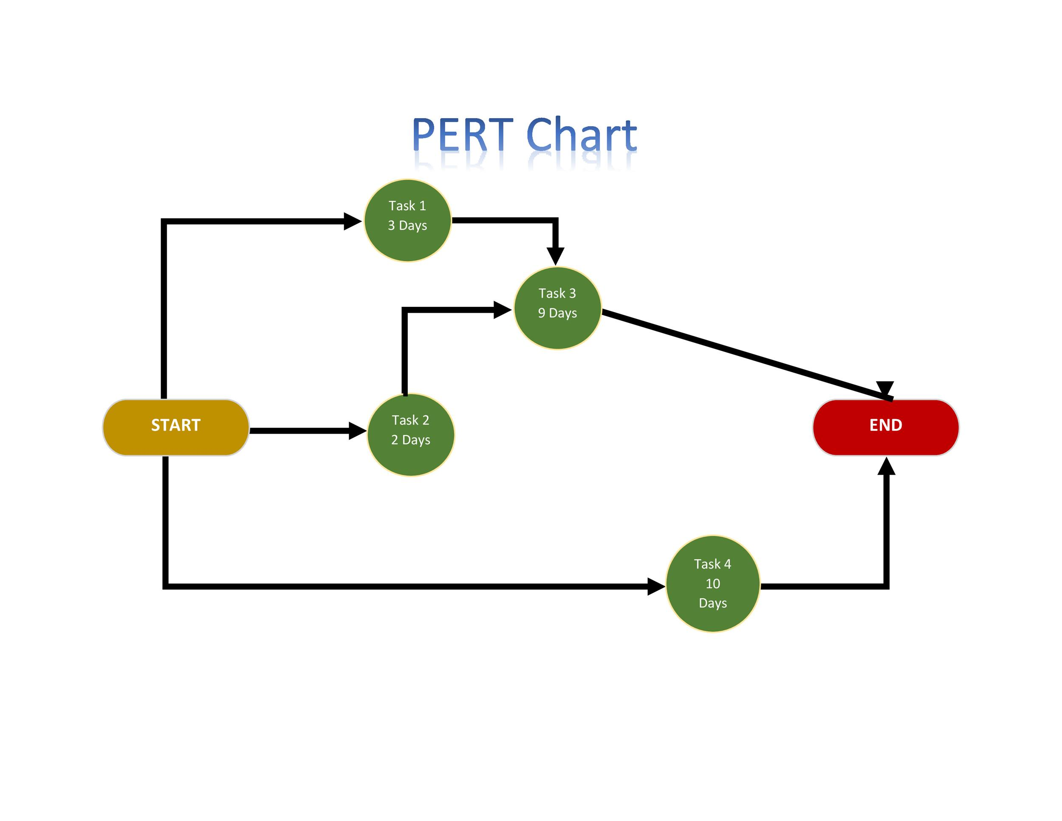

8. PROJECT SCHEDULING

We estimated the number of days for each task as follows:

* Task1 (Gathering Information) – 2 days
* Task2 (Analysis) – 5 days
* Task3 (System Design) – 2 days
* Task4 (Coding) – 6 days
* Task5 (Testing) –3 days

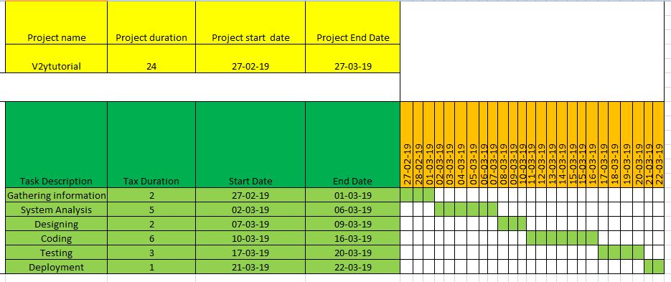

9. Appendices

**9.1 Coding&Screenshot**

**HTML CODE**

<!DOCTYPEhtml>

<htmllang="en">

<head>

    <metacharset="UTF-8">

    <metahttp-equiv="X-UA-Compatible"content="IE=edge">

    <metaname="viewport"content="width=device-width, initial-scale=1.0">

    <title>Weather-Forecasting</title>

    <linkrel="stylesheet"href="style.css">

    <linkrel="stylesheet"href="https://cdnjs.cloudflare.com/ajax/libs/font-awesome/6.4.0/css/all.min.css"

        integrity="sha512-iecdLmaskl7CVkqkXNQ/ZH/XLlvWZOJyj7Yy7tcenmpD1ypASozpmT/E0iPtmFIB46ZmdtAc9eNBvH0H/ZpiBw=="

        crossorigin="anonymous"referrerpolicy="no-referrer"/>

    <linkrel="stylesheet"href="https://cdnjs.cloudflare.com/ajax/libs/font-awesome/6.4.0/css/all.min.css"

        integrity="sha512-iecdLmaskl7CVkqkXNQ/ZH/XLlvWZOJyj7Yy7tcenmpD1ypASozpmT/E0iPtmFIB46ZmdtAc9eNBvH0H/ZpiBw=="

        crossorigin="anonymous"referrerpolicy="no-referrer"/>

    <linkrel="stylesheet"href="https://cdnjs.cloudflare.com/ajax/libs/font-awesome/6.4.0/css/all.min.css"

        integrity="sha512-iecdLmaskl7CVkqkXNQ/ZH/XLlvWZOJyj7Yy7tcenmpD1ypASozpmT/E0iPtmFIB46ZmdtAc9eNBvH0H/ZpiBw=="

        crossorigin="anonymous"referrerpolicy="no-referrer"/>

    <linkrel="stylesheet"href="https://cdnjs.cloudflare.com/ajax/libs/font-awesome/6.4.0/css/all.min.css"

        integrity="sha512-iecdLmaskl7CVkqkXNQ/ZH/XLlvWZOJyj7Yy7tcenmpD1ypASozpmT/E0iPtmFIB46ZmdtAc9eNBvH0H/ZpiBw=="

        crossorigin="anonymous"referrerpolicy="no-referrer"/>

    <linkrel="stylesheet"href="https://cdnjs.cloudflare.com/ajax/libs/font-awesome/6.4.0/css/all.min.css"

        integrity="sha512-iecdLmaskl7CVkqkXNQ/ZH/XLlvWZOJyj7Yy7tcenmpD1ypASozpmT/E0iPtmFIB46ZmdtAc9eNBvH0H/ZpiBw=="

        crossorigin="anonymous"referrerpolicy="no-referrer"/>

    <linkrel="stylesheet"href="https://cdnjs.cloudflare.com/ajax/libs/font-awesome/6.4.0/css/all.min.css"

        integrity="sha512-iecdLmaskl7CVkqkXNQ/ZH/XLlvWZOJyj7Yy7tcenmpD1ypASozpmT/E0iPtmFIB46ZmdtAc9eNBvH0H/ZpiBw=="

        crossorigin="anonymous"referrerpolicy="no-referrer"/>

        <linkrel="icon"href="img/clou.png">

</head>

<body>

    <divclass="container">

        <divclass="header">

            <divclass="search-box">

                <inputtype="text"class="input-box"placeholder="Enter Your Location....">

                <buttonclass="fa-solid fa-magnifying-glass"id="search-btn"></button>

            </div>

        </div>

        <divclass="location-not-found">

            <h1>sorry location not found......?</h1>

            <imgsrc="/img/error.jpg"alt="">

        </div>

        <divclass="weather-body">

            <imgsrc="/img/clear.png"alt=""class="weather-img">

            <divclass="weather-box">

                <pclass="temperature">0<sup>°C</sup></p>

                <pclass="description">Light rain</p>

            </div>

            <divclass="weather-details">

                <divclass="humidity">

                    <iclass="fa-solid fa-droplet"></i>

                    <divclass="text">

                        <spanclass="humidity"id="humi">0%</span>

                        <p>Humidity</p>

                    </div>

                </div>

                <divclass="wind">

                    <iclass="fa-solid fa-wind"></i>

                    <divclass="text">

                        <spanid="wind-speed">0km/H</span>

                        <p>Wind-speed</p>

                    </div>

                </div>

            </div>

        </div>

    </div>

    <!-- <script src="script.js"></script> -->

    <scriptsrc="index.js"></script>

</body>

</html>

* CSS CODE

* {

    margin: 0;

    padding: 0;

    box-sizing: border-box;

    border: none;

    outline: none;

    font-family: sans-serif;

}

body {

    min-height: 100vh;

    display: flex;

    justify-content: center;

    align-items: center;

    background-color: black;

}

.container {

    width: 400px;

    height: min-content;

    background-color: #fff;

    border-radius: 12px;

    padding: 28px;

    border: 3pxsolidred;

}

.search-box {

    width: 100%;

    height: min-content;

    display: flex;

    justify-content: space-between;

    align-items: center;

    /* background-color: #e6f5fb; */

}

.search-boxinput {

    width: 84%;

    font-size: 20px;

    text-transform: capitalize;

    color: black;

    border-radius: 14px;

    padding: 12px16px;

    background-color: #e6f5fb;

}

.search-boxinput::placeholder {

    color: black;

}

.search-boxbutton {

    background-color: #e6f5fb;

    width: 46px;

    height: 46px;

    border-radius: 50%;

    cursor: pointer;

    font-size: 20px;

}

.search-boxbutton:hover {

    color: #fff;

    background-color: black;

}

.weather-body {

    display: flex;

    justify-content: center;

    align-items: center;

    flex-direction: column;

    margin-block: 20px;

}

.weather-bodyimg {

    width: 60%;

}

.weather-box {

    margin: block20px;

    text-align: center;

}

.weather-box.temperature {

    font-size: 45px;

    font-weight: 800;

    position: relative;

}

.weather-box.temperaturesup {

    font-size: 20px;

    position: absolute;

    font-weight: 600;

}

.weather-box.description {

    font-size: 20px;

    font-weight: 600;

    text-transform: capitalize;

}

.weather-details {

    width: 100%;

    display: flex;

    justify-content: space-between;

    align-items: center;

    margin-top: 25px;

}

.weather-details.humidity {

    display: flex;

    align-items: center;

    justify-content: center;

}

.weather-details.wind {

    display: flex;

    align-items: center;

    justify-content: space-between;

}

.weather-detailsi {

    font-size: 35px;

}

.weather-details.text {

    margin-left: 10px;

    font-size: 16px;

}

.textspan {

    font-size: 20px;

    font-weight: 600;

}

.location-not-found {

    margin-top: 25px;

    text-transform: capitalize;

    display: flex;

    align-items: center;

    justify-content: center;

    flex-direction: column;

    display: none;

}

.location-not-foundimg {

    width: 100%;

}

* JAVASCRIPT CODE

letinputbox=document.querySelector(".input-box");

letsearchbtn=document.getElementById('search-btn');

letweather_img=document.querySelector('.weather-img');

lettemperature=document.querySelector(".temperature");

letdescription=document.querySelector(".description");

letHumidity=document.getElementById("humi");

letwind_speed=document.getElementById("wind-speed");

letlocation_not=document.querySelector('.location-not-found');

letweather_body=document.querySelector('.weather-body');

// calling for api help of opencurrent.map.in

asyncfunctioncheckWeather(city) {

    constapi_key="c61fe35b65760cde15ec158bc914af1e";

    consturl=`https://api.openweathermap.org/data/2.5/weather?q=${city}&appid=${api_key}`;

    constweather_data=awaitfetch(`${url}`).then(response=>response.json());

    console.log(weather_data);

    if (weather_data.cod==`404`) {

        location_not.style.display="flex";

        weather_body.style.display="none";

    }

    else {

        location_not.style.display="none";

        weather_body.style.display="flex";

    }

    temperature.innerHTML=`${Math.round(weather_data.main.temp-273.15)}°C`;

    wind_speed.innerHTML=`${(weather_data.wind.speed)}`;

    Humidity.innerHTML=`${weather_data.main.humidity}%`;

    description.innerHTML=`${weather_data.weather[0].description}`;

    // case switch for condition/

    switch (weather_data.weather[0].main) {

        case'Clouds':

            weather_img.src="/img/clou.png";

            break;

        case'Clear':

            weather_img.src="/img/clear.png";

            break;

        case'Rain':

            weather_img.src="/img/rain.png";

            break;

        case'Mist':

            weather_img.src="/img/mist.jpg";

            break;

        case'Snow':

            weather_img.src="/img/snow.jpg";

            break;

        case'Haze':

            weather_img.src="/img/hazee.png";

            break;

    }

}

// output show

searchbtn.addEventListener('click', () => {

    checkWeather(inputbox.value);

});

// console.log(weather_data);

Working

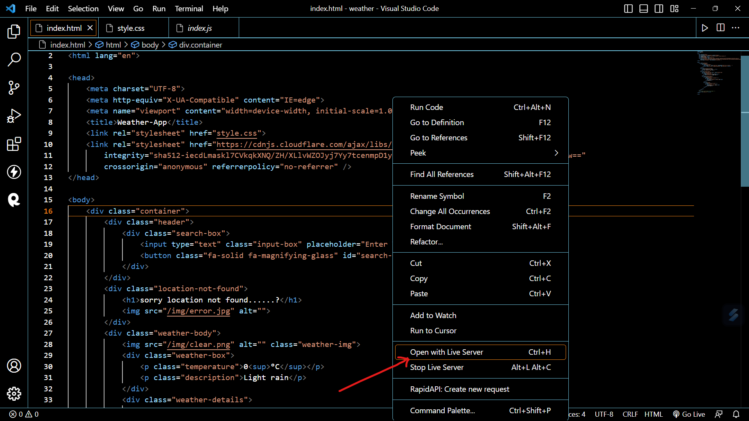

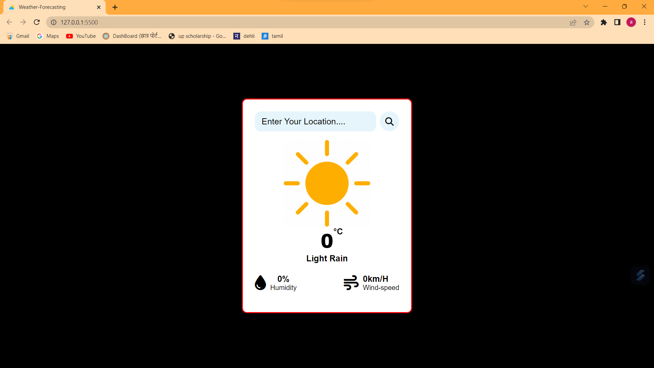

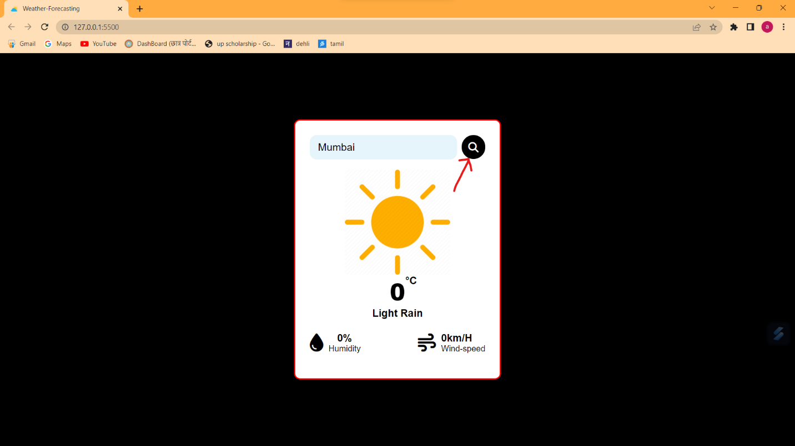

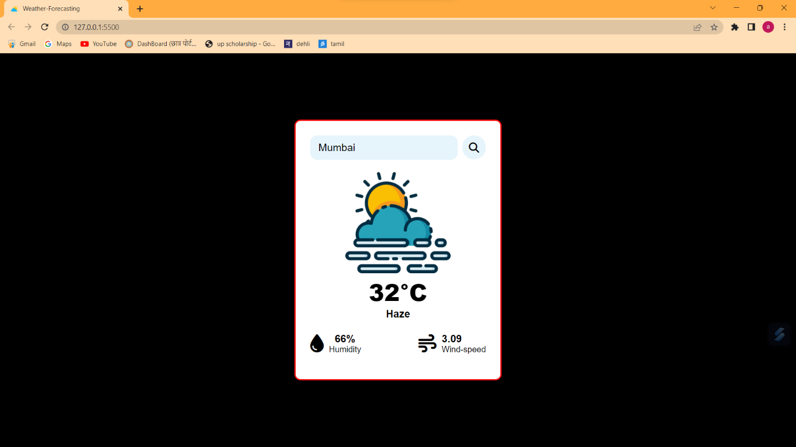

Site Map:

_____________________________________________

A *sitemap* is a file where you provide information about the pages, videos, and other files on your site, and the relationships between them. Search engines like Google read this file to crawl your site more efficiently. A sitemap tells Google which pages and files you think are important in your site, and also provides valuable information about these files. For example, when the page was last updated and any alternate language versions of the page.

You can use a sitemap to provide information about specific types of content on your pages, including [video](https://developers.google.com/search/docs/crawling-indexing/sitemaps/video-sitemaps), [image](https://developers.google.com/search/docs/crawling-indexing/sitemaps/image-sitemaps), and [news](https://developers.google.com/search/docs/crawling-indexing/sitemaps/news-sitemap) content. For example:

* A sitemap *video entry* can specify the video running time, rating, and age-appropriateness rating.
* A sitemap *image entry* can include the location of the images included in a page.
* A sitemap *news entry* can include the article title and publication date.

# 10. Testing

## TestingTechniquesUsed

Multiple testing methodologies are used by the Movie Ticket Booking System (MTB) toguarantee the accuracy and dependability of the programme. Some of the testing methodsusedare as follows:

Unit Testing: Unit testing is carried out to independently test each component or unitof the software. It focuses on examining each unit's functioning and making sure itperformsasintended.Thedevelopersthemselvesoftenwriteunittests,whichfocusoncertaincodemodules or functionalities.

Integration testing: Integration testing: Integration testing is done to examine howwellvarioussystemmodulesorcomponentsworktogether.Itseekstofindanyproblems or flaws that might appear when combining several units. Integration testsconfirm that the components function properly together and that data is accuratelytransferredbetween them.

SystemTesting:Systemtestingentailscheckingthesystemasawholetomakesureitcomplies with the requirements and operates as intended. It focuses on testing thesystem from beginning to end, taking into account all of its parts, functions, andfeatures.Testers or qualityassuranceteams oftencarryout system testing.

Error Handling Testing: Testing for error handling is done to ensure that the systemcangracefullyhandledifferentkindsoferrorsandexceptions.Itfocusesontestingerrorscenariosandensuringthatthesystemrecoversfromorhandlesproblemscorrectly,aswellas displayingthe proper errormessages.

* 1. **TestReports forUnit andSystemTestCase 2**

### *TestReportforUnit TestCase2:

**TestCase:**AddMovietoDatabase

**TestCaseID:** UT-2

**Date:**13-05-2023

**Tested by:**ShivamSaini

**Status:**Passed

#### Description:

The purpose of this unit test case is to verify that the "Add Movie to Database"functionality is working as expected. This test focuses on adding a new movie to thedatabase and ensuringthat themoviedetails arecorrectlystored.

#### TestSteps:

* + 1. Entervalidmoviedetails (id,title,genre,year,rating,price).
    2. Verifythat the movie is successfullyadded to thedatabase.
    3. Retrievethemoviedetails andcomparethem withtheenteredvalues.
    4. Confirmthatallthedetailsmatchandthemovieisstoredaccuratelyinthedatabase.

#### TestResults:

1. Validmoviedetailswereenteredsuccessfully.
2. The"Add Movie" functionalityexecuted withoutanyerrors.
3. Themoviewasadded tothedatabasewithoutanyissues.
4. Retrievedmoviedetailsmatchtheenteredvalues.
5. Alldetails match,confirmingtheaccurate storageof themovieinthedatabase.

#### Conclusion:

Unit Test Case 2, which focuses on the "Add Movie to Database" functionality, haspassed successfully. The movie was added to the database accurately, and all theentereddetails werestored correctly

1. **FutureScopeandFurtherEnhancement**

Opportunities exist for increasing forecast skill at all time ranges. However, realizing these opportunities will require further research, close international cooperation and coordination, improved observations of the atmosphere, ocean, and land surface, and the incorporation of these observations into numerical models.

Also, benefit will be derived from higher spatial resolution of numerical models; increasingly powerful supercomputers; wider use and improvement of model ensembles; the development of data mining and visualization methods that enable forecasters to make better use of model guidance; and collaborative forecast development activities among operational forecasters and researchers.

Beyond improving the forecast itself, improvement in the communication and best use of forecast information is also needed. Research integrating social science is key in identifying opportunities for future advances. For example, research conducted by social scientists across multiple disciplines has found that delivering weather warnings across multiple media increases the likelihood that people will get and act upon this information.

Scholars have conducted numerous studies on different public groups about perceptions of risk and uncertainty.

They are also working to explore the relative value of effective communication of accurate weather forecasts to appropriate decision-makers.

**FurtherEnhancement:**

The Movie Ticket Booking System (MTB) for Miraj Cinemas can be further enhanced toprovideadditionalfeaturesandimprovetheoveralluserexperience.Herearesomesuggestionsforfurther enhancements:

Online Ticket Booking: Include a feature that enables clients to order tickets onlineusingawebsite[6]ormobileapplicationfromthecomfortoftheirhomes.Convenienceandaccessibilitywould result from this,increasingtheclient base.

Seat Selection: Enhance the seat selection process, customers can see the availableseats in real-time and choose their preferred seating position. This feature can alsoincludeseatcategoriessuch asVIP,couple seating,orwheelchair-accessibleseats.

Social Media Integration: Incorporate social media integration to allow customers toshare their movie plans or ticket bookings on platforms like Facebook or Twitter. Thiscanhelp generatebuzzandattractmorecustomersthroughword-of-mouth marketing.

Mobile Ticketing: Enable customers to use their mobile devices as tickets [7] byintegrating QR code or barcode scanning technology. This eliminates the need forphysicalticketsand enhancestheconvenienceandefficiencyof theticketingprocess.

Integration with Payment Gateways:Integrate secure paymentgateways[8]tofacilitate seamless and secure online transactions. This enhances customer trust andconfidencein theticket bookingprocess.

These enhancements will contribute to an improved user experience, increased customersatisfaction, and the overall success of the Movie Ticket Booking System (MTB) for MirajCinemas.

1. **Conclusion**

In summary, weather forecasts are increasingly accurate and useful, and their benefits extend widely across the economy. While much has been accomplished in improving weather forecasts, there remains much room for improvement. The forecasting community is working closely with multiple stakeholders to ensure that forecasts and warnings meet theirspecific needs. Simultaneously, they are developing new technologies and observational networks that can enhance forecaster skill and the value of their services to their users.

1. **Bibliography**

## Robin Nixon , Learning PHP, MySQL, JavaScript, and CSS: fourth Edition : the structure of php [pp 38-56], data base design [pp 209-219], expressions in javascript[pp 331-339], introduction in CSS[pp 413-450]

Brett McLaughlin , PHP & MySQL: fivth Editon: The Missing Manual [pp 250-265]

1. W3schools.com connection,<https://www.w3schools.com/php/php_mysql_connect.asp>last access- Feb 5, 2024